A SONG FOR THE GENERATIONS
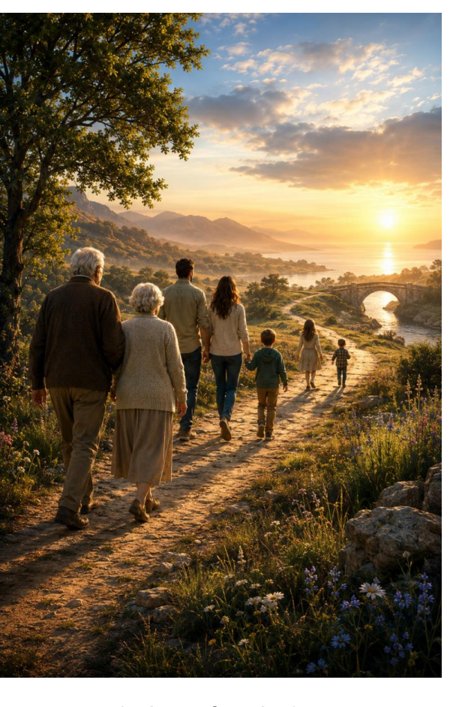
Stories Worth Passing On
A DAWN Collection on Family, Inheritance, Belonging, and Home
Vidar Lee Byberg
Founder, Author, DAWN
We entered a story already in progress. One day others will continue it after us.
16 Songs • 16 Chapter Stories • 16 Illustrations • 16 Chapter Audio Recordings
One Journey

WHAT WILL WE PASS ON?
Every generation receives a story. Every generation leaves one behind.
Long before we spoke our first words, others were already shaping our lives. A mother sang. A father worked. A grandparent prayed. A teacher encouraged. A friend believed in us.
Someone built a bridge we did not see. Someone carried a burden we did not know existed. Someone planted a seed whose fruit we now enjoy.
We entered a story already in progress—a story of sacrifice, faith, courage, and love.
Most of us do not recognize the full value of these gifts until much later. Perhaps when we become parents ourselves. Perhaps when we bury a grandparent. Perhaps when we discover an old photograph. Perhaps when an empty chair suddenly reminds us how much someone meant.
Then we begin to understand. The greatest inheritances are rarely found in bank accounts. They are found in character, wisdom, faith, values, stories, and love.
And one day, others will inherit something from us. The question is not whether we will leave an inheritance. The question is: What will we pass on?
A Song for the Generations was created to explore that question through music, stories, artwork, narration, and conversation—not merely to preserve memories, but to help preserve wisdom; not merely to honor the past, but to help shape the future.

THE COLLECTION JOURNEY
The songs in this Collection span thousands of years. Some are inspired by Scripture. Some by history. Some by famous families. Some by ordinary families. Yet all of them explore the same enduring questions:
Inheritance — What have we received from those who came before us? The gifts, wounds, stories, faith, examples, and choices that continue to shape our lives.
Awakening — What are we searching for? Purpose, identity, truth, meaning, and the realization that there must be something more.
The Gift — Who helped make us who we are? Parents, grandparents, teachers, mentors, friends, and the people whose investments continue to shape our lives.
Belonging — Where do we belong? In family, community, friendship, faith, and a story larger than ourselves.
Home — Where is the journey leading? Toward restoration, reunion, the fulfillment of every good promise, and ultimately Home.
This is not merely the journey of the Collection. It is the journey of every human life.

THE COLLECTION JOURNEY
A Journey Through Life. A Story for Every Generation.
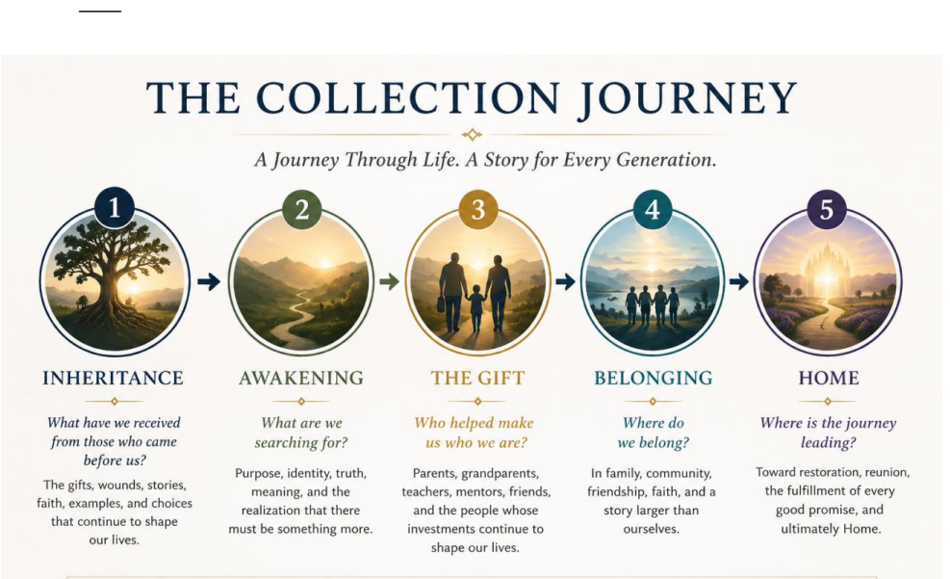
THE COLLECTION AT A GLANCE
The songs in this Collection span generations, families, friendships, faith, loss, hope, and ultimately Home. Each song stands on its own. Together they form one larger journey.

THE COLLECTION AT A GLANCE
Sixteen Song & Story Packages — One Connected Journey
# | Song title | Theme / Description
1 | A Song for the Generations | Every generation receives a story and leaves one behind.
2 | The Brother’s Keeper | Responsibility, family, and the consequences of our choices.
3 | Same Blood, Different Roads | Shared beginnings do not guarantee shared destinies.
4 | Three Million Sons and Fathers | Humanity connected through generations.
5 | Ten Thousand Nights | The search for identity, purpose, and belonging.
6 | The Lion Melted the Fog | Truth breaking through confusion and uncertainty.
7 | The Treasure Gathered There | Discovering that people are life's greatest treasure.
8 | The Silver Eagles | Wisdom, aging, mentorship, and legacy.
9 | A Flickering Light | Receiving, carrying, and passing on Heaven's gift from one generation to the next.
10 | When the Maker Made Us Family | The gift and design of belonging.
11 | When (with the generations re-gathered) | The joyful reunion of generations and the fulfillment of long-held hope.
12 | Fully Alive | Living with purpose, gratitude, and hope.
13 | We Are Sailing | Trusting the journey even when the destination is unseen.
14 | Wanted Them with Me Before Creation | Before the world began, Love desired to gather His people to Himself.
15 | Home | The fulfillment of every longing and the gathering of generations.
16 | He Called Him by Name | The Shepherd Walks Us Home — my father's homegoing, the Shepherd's promise, and the hope of reunion.
Featured Final Song — He Called Him by Name

The Shepherd Walks Us Home — Placed after Home as the collection’s personal epilogue: my father’s homegoing story, held in the larger promise of eternal Home.

ONE STORY
These are not sixteen separate stories. They are sixteen windows into one larger story.
The story of how people become families. How families become generations. How generations shape civilizations. And how every human heart ultimately longs for Home.
Some stories begin thousands of years ago. Some happened only yesterday. Some involve well-known historical figures. Some belong to families no one outside their circle will ever know.
Yet all of them ask the same questions: What matters most? What is worth passing on? What kind of inheritance are we leaving behind? And what story will future generations tell about us?
MORE THAN AN ALBUM
Some stories are too important to be heard only once. That is why A Song for the Generations is more than an album.
Each Song & Story Package combines:
• An Original Song
• A Companion Story
• Original Illustration
• Chapter Audio Recording
• Deep Well Further Readings
Together, these elements create an experience designed not merely to entertain, but to inspire meaningful conversations between generations. This Collection is not primarily about songs. It is about conversations—between grandparents and grandchildren, between parents and children, and between mentors and those they guide.

WHY THIS MATTERS NOW
Most people want the same things: to belong, to matter, to be remembered, to know their lives made a difference, and to pass something meaningful to those who follow.
Yet many people struggle to find opportunities for the conversations where those gifts are shared—the stories, the lessons, the memories, the wisdom, and the hopes.
Long after the songs have ended, something else remains: a grandfather's lesson, a mother's sacrifice, a friend's encouragement, a family's faith, a story told around a table, a memory shared with a child, a life that quietly shaped another life.
This Collection exists because those gifts matter. And because future generations deserve to inherit more than information. They deserve wisdom. They deserve belonging. They deserve stories worth remembering.

HELP BRING THE COLLECTION TO LIFE
A Song for the Generations is designed as a complete Collection of sixteen Song & Story Packages.
Together, these resources are intended to inspire conversations across generations, preserve stories worth remembering, and encourage lives marked by gratitude, purpose, faith, and hope.
The estimated development cost is approximately:
Current Status
• 16 songs written
• 16 demo recordings completed
• Companion stories in development
• Illustration development beginning
• Website development underway
Funding Goal
• Sponsor a Package: $3,200
• Complete Collection: $51,200
Support opportunities include:
• Sponsor a Package
• Sponsor Multiple Packages
• Support the Collection as a Whole
• General Project Support
Every contribution helps preserve and share stories worth passing on.

WHY DAWN?
A Song for the Generations is the first Collection within DAWN.
DAWN exists to create stories, music, conversations, and creative works that explore faith, family, human flourishing, and the larger story that gives meaning to our lives.
This Collection focuses on generations. Future Collections will explore additional themes, questions, and stories. Together they form part of a larger creative vision dedicated to truth, goodness, beauty, and Home.
ABOUT THE AUTHOR
Vidar Lee Byberg brings more than thirty years of leadership experience across energy, agriculture, technology, and education. His career spans public and private companies and nonprofit organizations, with work in the United States and internationally encompassing economic analysis, business development, entrepreneurship, and organizational leadership. Alongside that professional journey, Vidar has pursued a lifelong interest in faith, human flourishing, music, and storytelling. Through DAWN, he brings these interests together in books, songs, and artistic collaborations exploring beauty, goodness, truth, and the inheritance we pass to future generations.

JOIN THE STORY
Every generation receives a story. Every generation leaves one behind. The question is not whether we will leave an inheritance. The question is what kind.
What stories will future generations tell? What wisdom will they inherit? What examples will they follow? What gifts will remain?
We invite you to become part of that story. Share it. Encourage it. Pray for it. Sponsor it. Help preserve stories worth passing on.
Because some stories are too important to lose. And some gifts are too valuable not to share.
CONTACT
Vidar Lee Byberg Founder, Author, DAWN
Email: byberg@dawn.education Website: www.dawn.education Phone: 320-905-2887

FINAL NOTE
The sixteen songs featured in this Collection have already been written and recorded in demo format, forming the foundation for the next phase of professional development.
Families shape generations.
Generations shape civilizations.
Civilizations find their meaning within a greater story.
And that story ultimately leads Home.
Home remains the Collection's grand climax. He Called Him by Name now serves as the personal epilogue—my father's homegoing held within the larger promise of eternal Home.

